**/blend**

**Blend 1:**

(This one is from Pinterest blend)

**Image 1:** <https://s.mj.run/iITPEUj63Pg>

**Image 2:** <https://s.mj.run/0ZfmMleKxfw>

**Generated Image:**

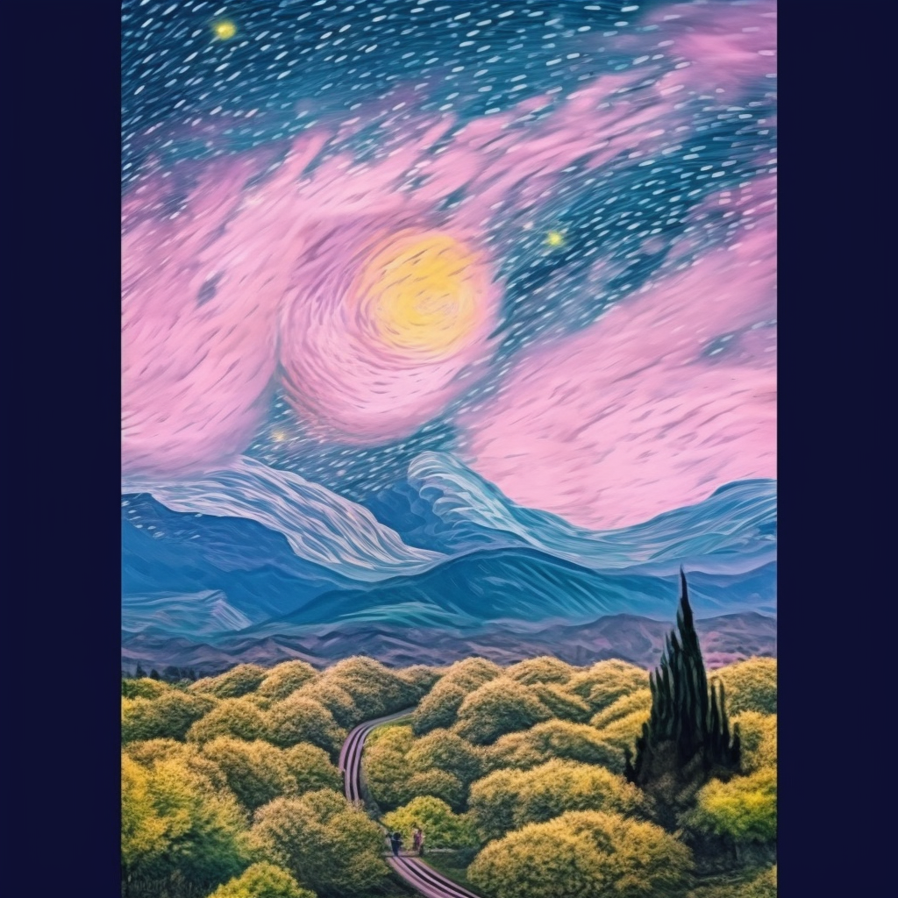

**Image 1:** <https://s.mj.run/9SrNHFUVnqE>

**Image 2:** <https://s.mj.run/StkGT11RdPo>

**Generated Image:**

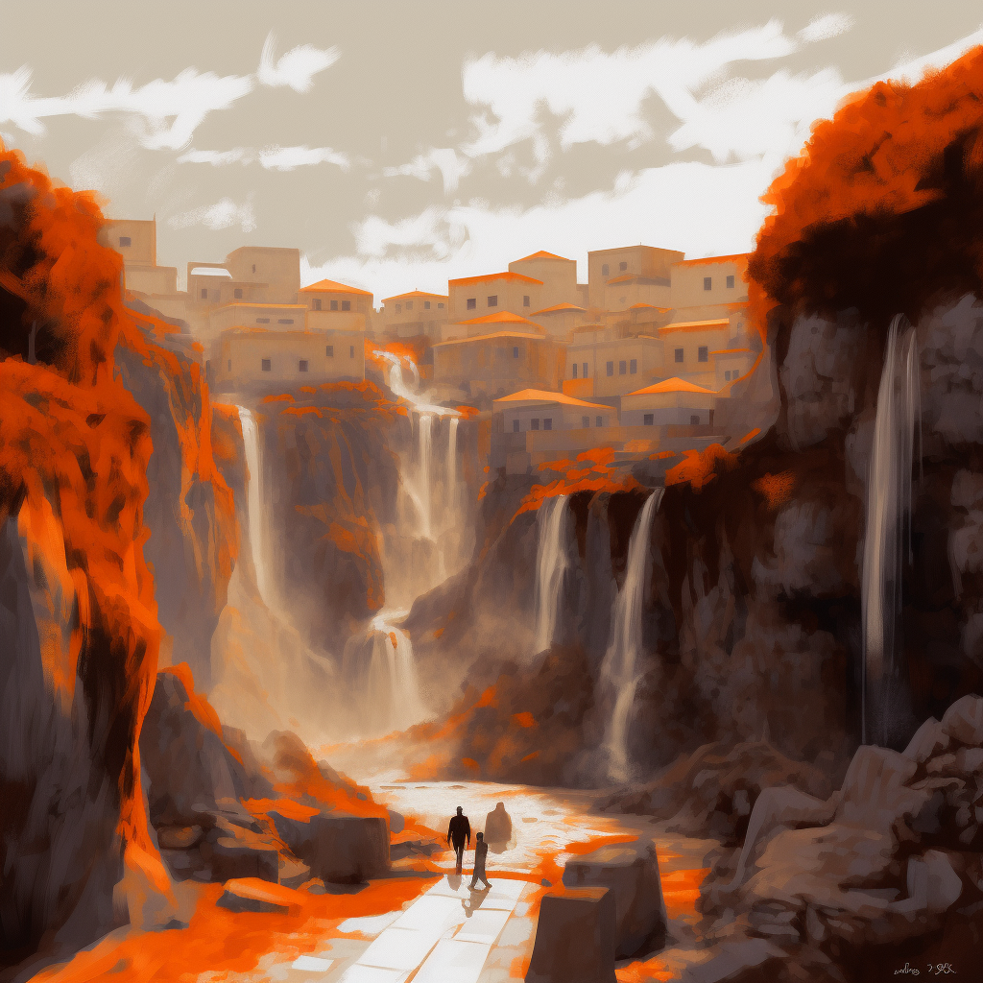

**Image 1:** <https://s.mj.run/PktJlT8G-NI>

**Image 2:** <https://s.mj.run/MIExSjJwTwU>

**Generated Image:**

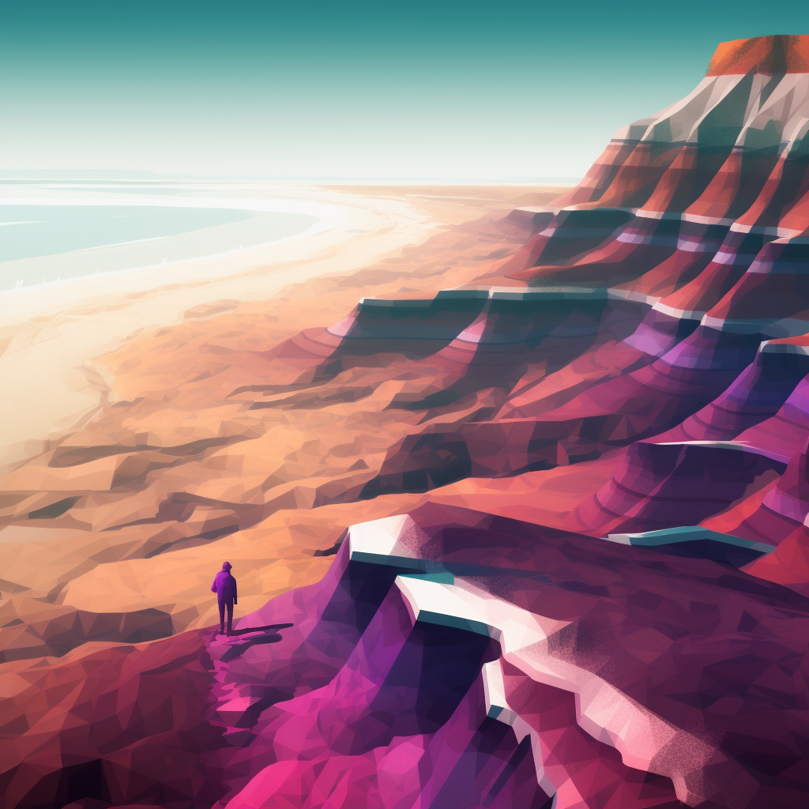

**Image 1:** <https://s.mj.run/qfVpFOeZenU>

**Image 2:** <https://s.mj.run/ysk4v2Hjip0>

**Generated Image:**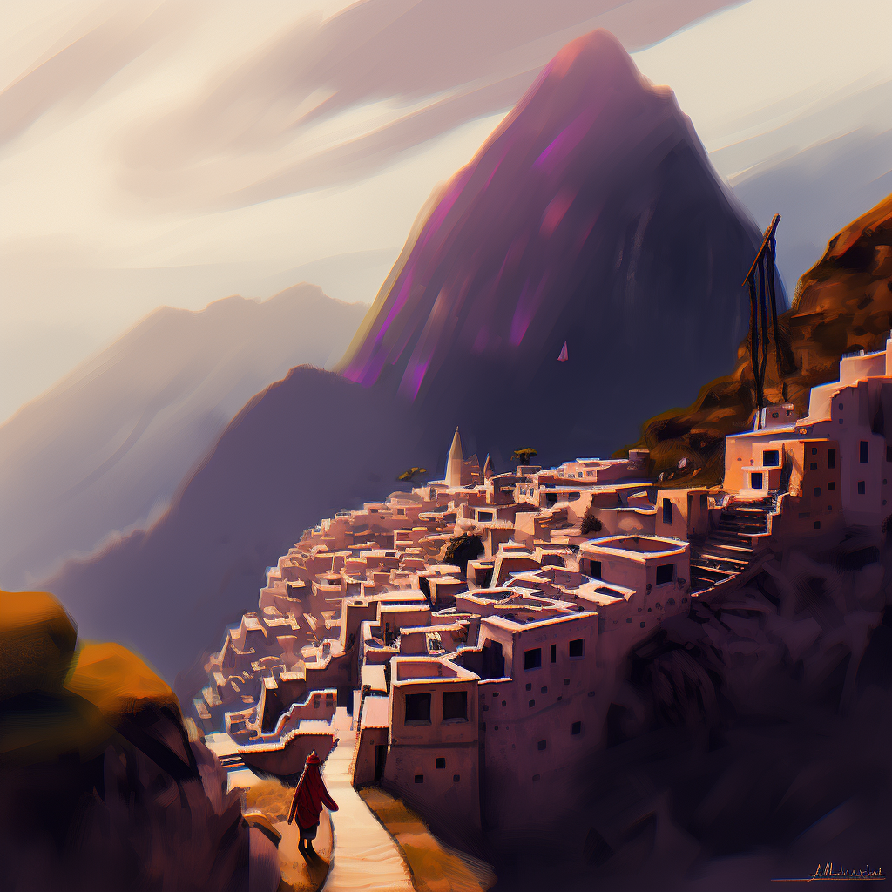

**Image 1:** <https://s.mj.run/-C1DKCAPc6A>

**Image 2:** <https://s.mj.run/oOvVyaQ9Ko0>

**Generated Image:**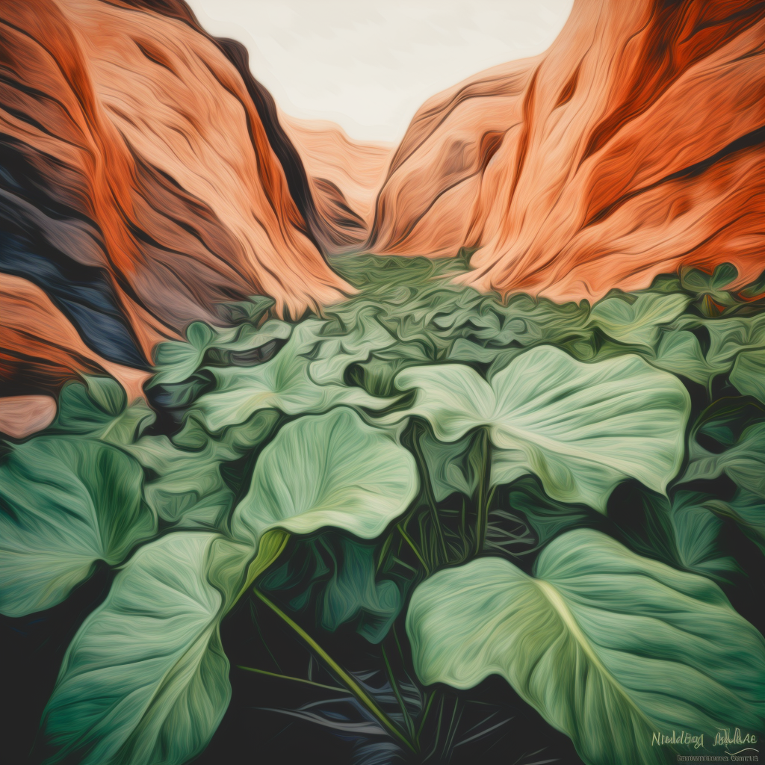

**Image 1:** <https://s.mj.run/r_JvHtToX5I>

**Image 2:** <https://s.mj.run/i-Dkm1RajFM>

**Generated Image:**

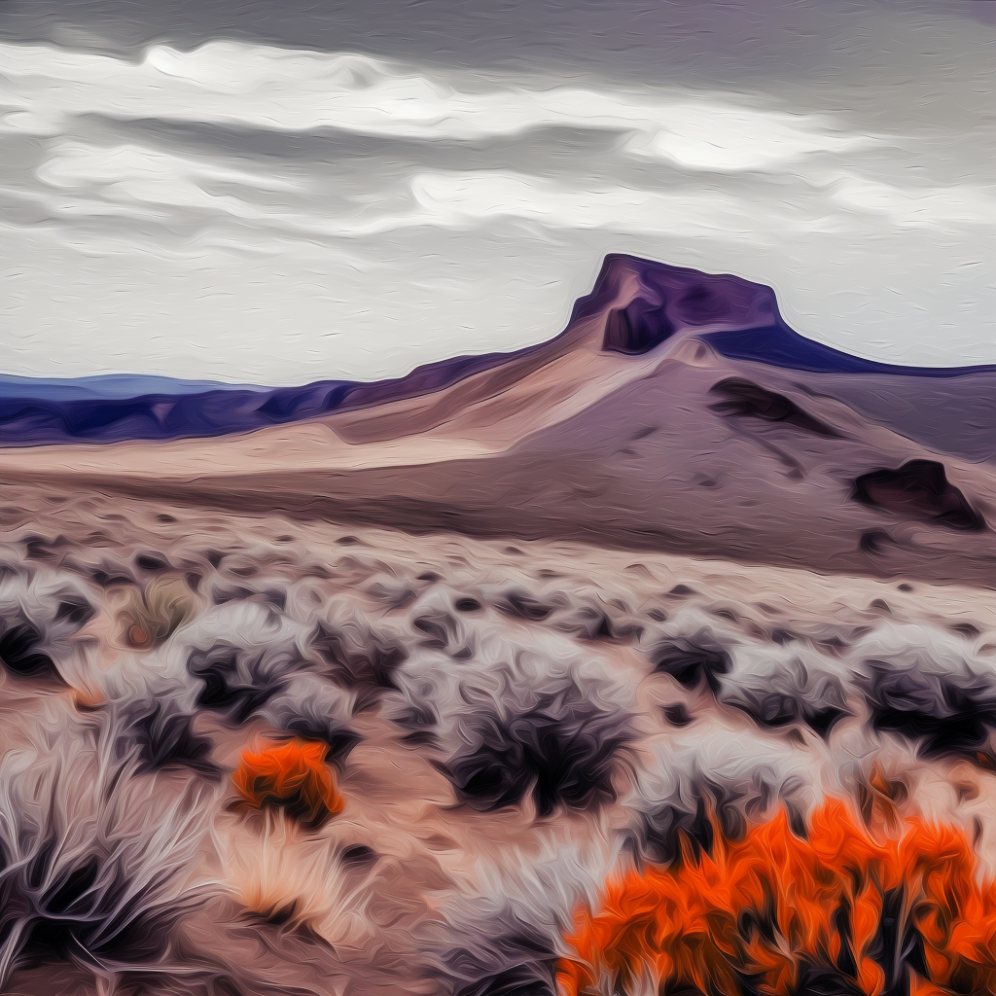**Generated Image:**

**Image 1:** <https://s.mj.run/3Tpf8w2JvKk>

**Image 2:** <https://s.mj.run/1iwwKwrbb_I>

**Generated Image:**

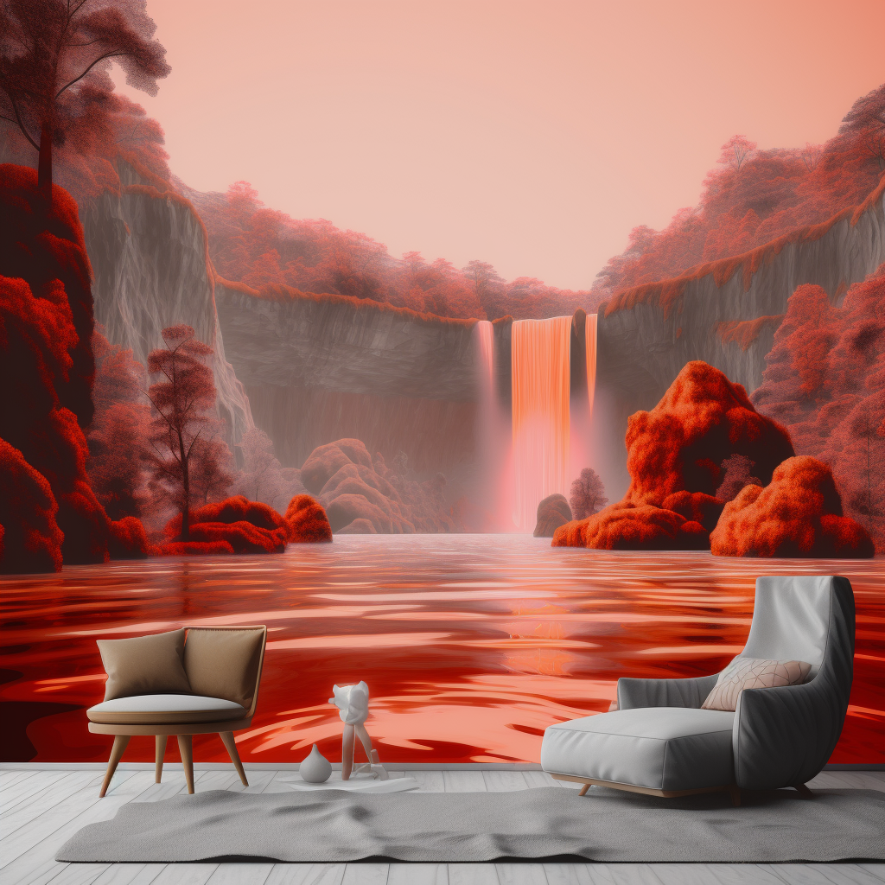

**Image 1:** <https://s.mj.run/uutMkmlXGMM>

**Image 2:** <https://s.mj.run/vx1VjkckIrc>

**Generated Image:**

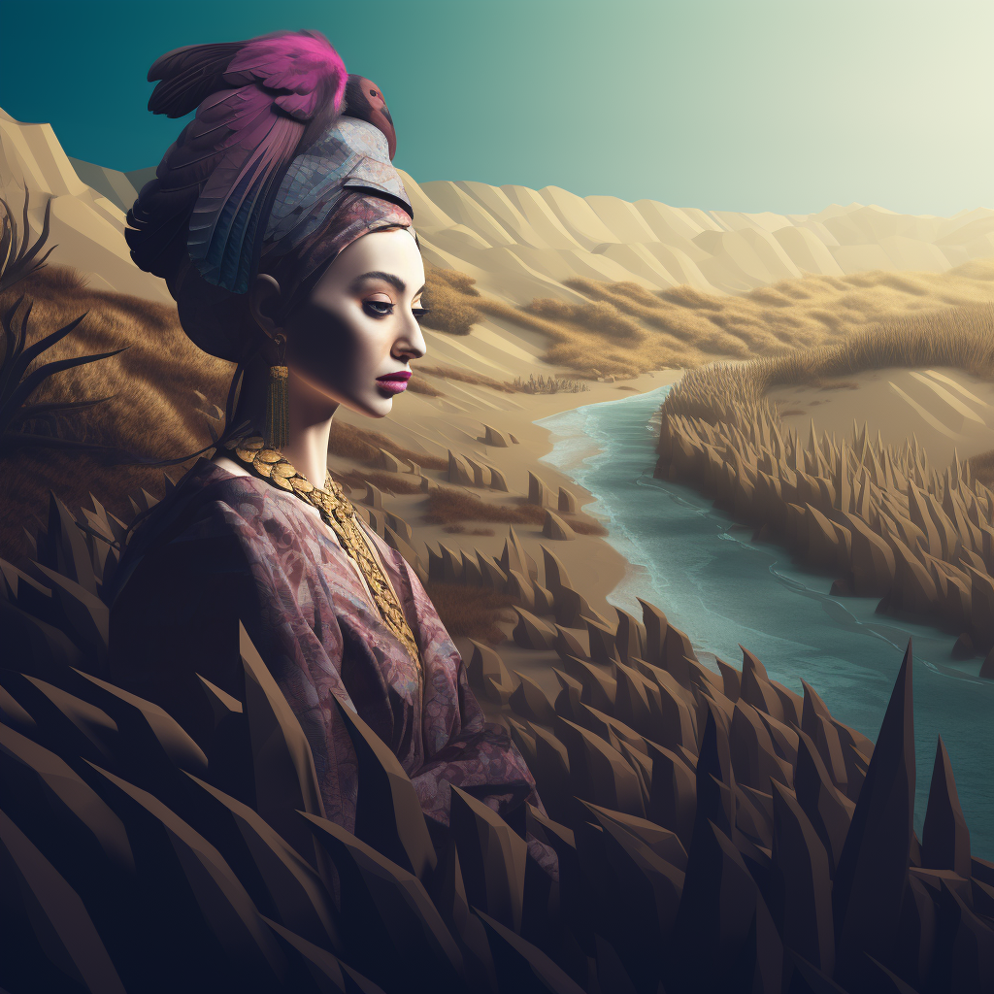

**Image 1:** <https://s.mj.run/WKX-l7-JKNc>

**Image 2:** <https://s.mj.run/2EXiBOr5h8g>

**Generated Image:**

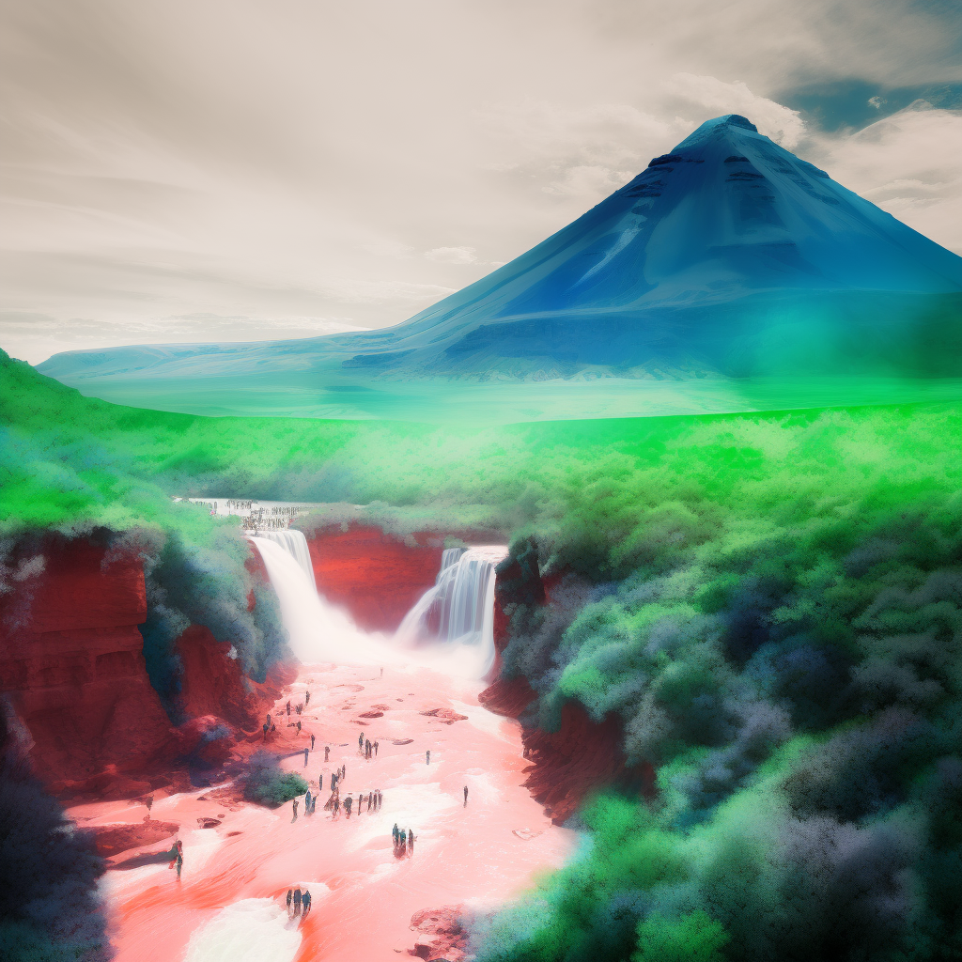

**Image 1:** <https://s.mj.run/3RxnWl4GPYo>

**Image 2:** <https://s.mj.run/USXC267cLpw>

**Generated Image:**

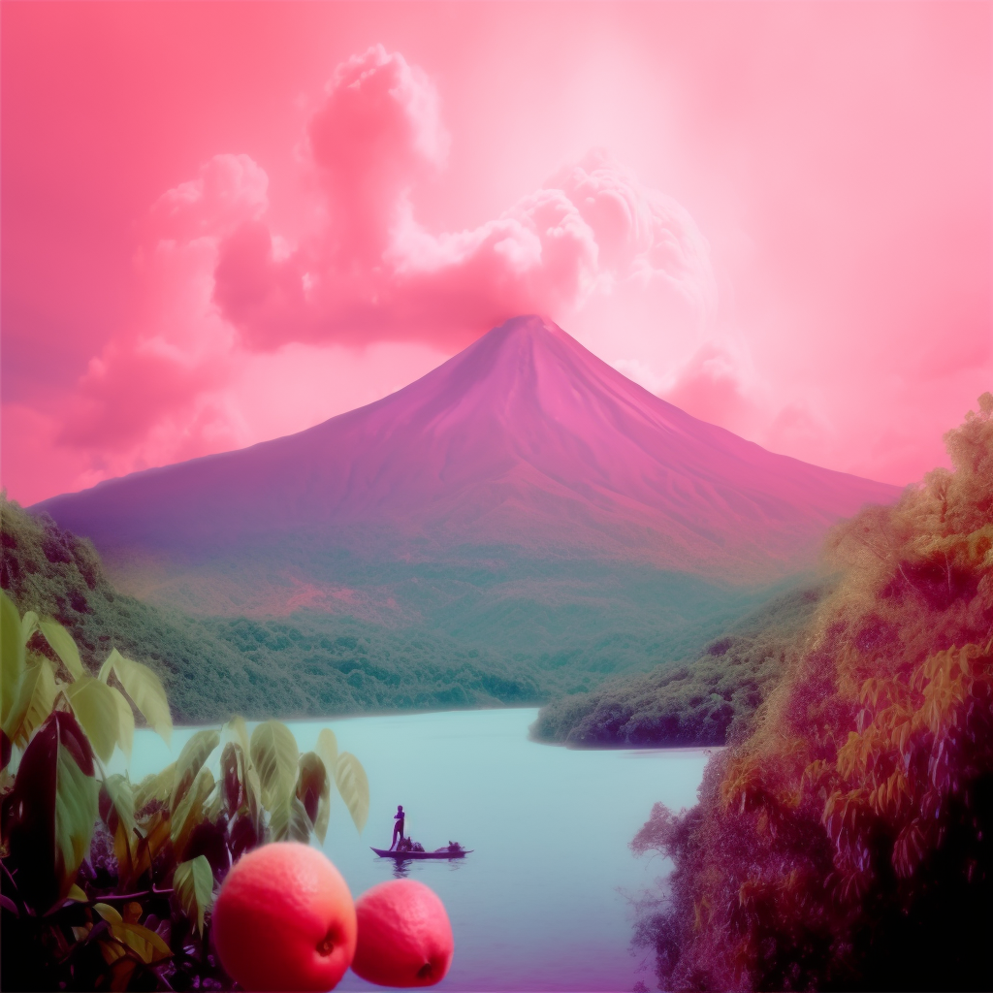

**Image 1:** <https://s.mj.run/LM7j-mrGN6o>

**Image 2:** <https://s.mj.run/oFvyacJVm2s>

**Generated Image:**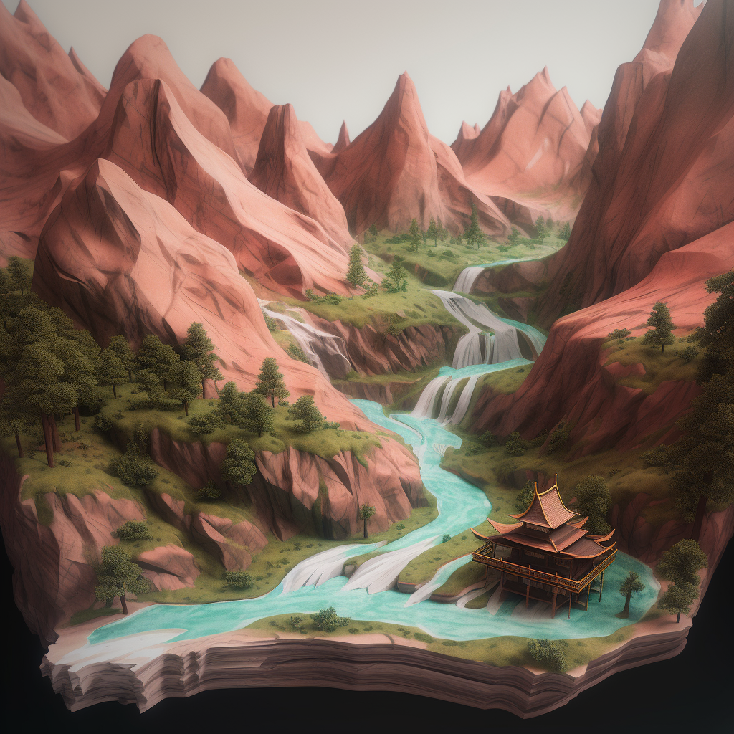

**Image 1:** <https://s.mj.run/sJsHgRYs0CI>

**Image 2:** <https://s.mj.run/f-exvwgxmEI>

**Generated Image:**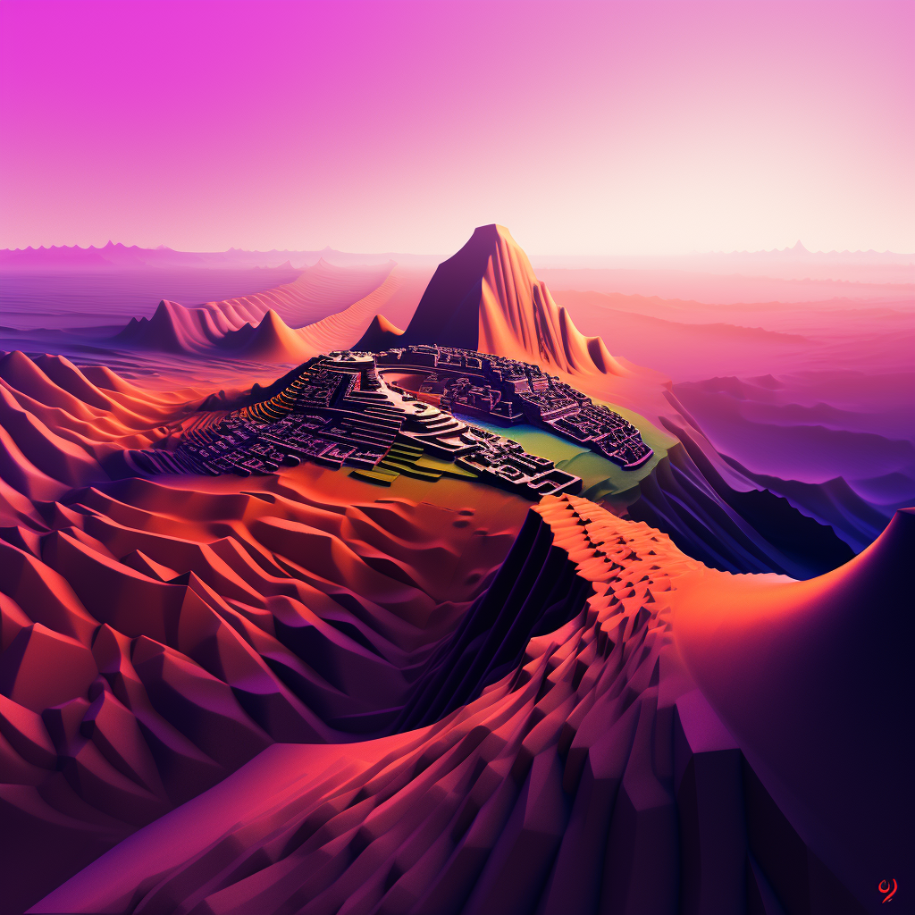

**Image 1:** <https://s.mj.run/t8gbGhDUiYk>

**Image 2:** <https://s.mj.run/zBmsW_1lwSA>

**Generated Image:**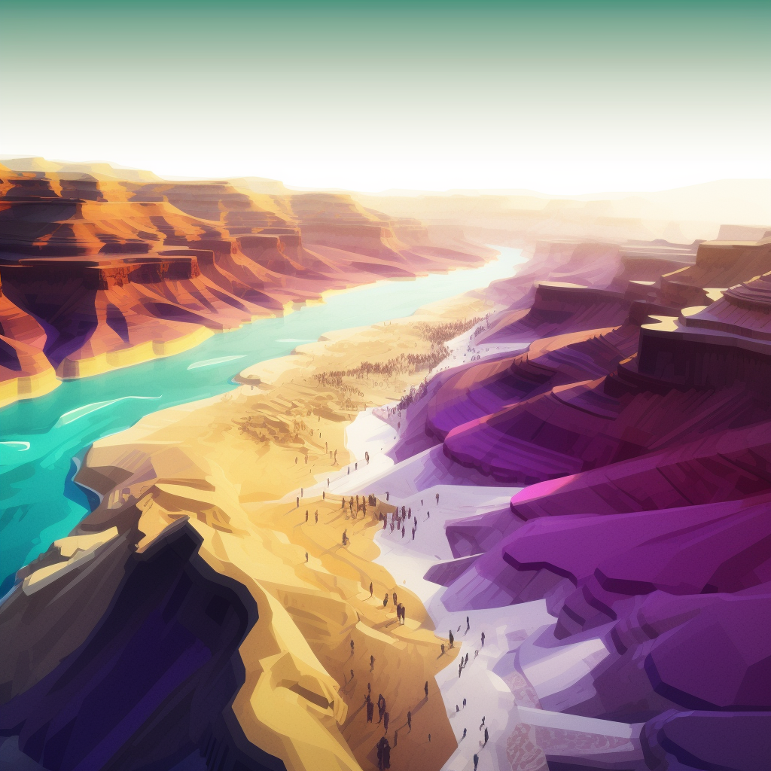

**Image 1:** <https://s.mj.run/n2f-f-6MCio>

**Image 2:** <https://s.mj.run/vkHZ6XVcrEk>

**Generated Image:**

